  Safety Data Sheet  Bio Block – Last updated 11/20/24 | 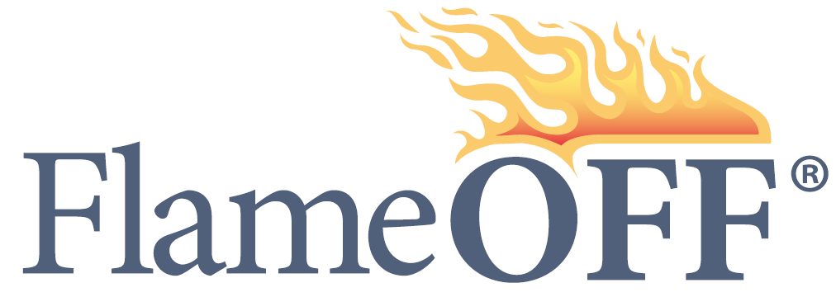

FlameOFF Coatings
Website: www.flameoffcoatings.com
Phone: 1-888-815-3370
1. PRODUCT IDENTIFICATION
Product Name: FlameOFF Bio Block
2. COMPOSITION
Ingredients | Concentration | CAS Number | ACGIH TLV | OSHA PEL
Proprietary | 19-25% | N/A | N/A | N/A
Proprietary | 3-5% | N/A | N/A | N/A
Proprietary | 4-7% | N/A | N/A | N/A
Water | 70-81% | 7732-18-5 | N/A | N/A

3. CHEMICAL AND PHYSICAL PROPERTIES
Appearance | Milky liquid | V.O.C: | 0g/litter
Color | Milky White | Vapor density | Not Determine
State | Liquid | Boiling point | 100˚C
pH | 7.5 | Solubility in Water | Soluble
Viscosity | 1.002 mpa | Percent Volatile volume | 0 VOC
Specific Gravity | Heavier than water | Evaporation Rate | Less than water
Material VOC | 0 VOC | Flash Point | N/A

4. FLAMMABILITY AND EXPLOSIVE PROPERTIES
Flash Point: N/A
Recommended Extinguishing Agents: Non-combustible
Unusual Fire or Explosion Hazards: None
Compressed Gases: None
Pressure at Room Temp: N/A

5. REACTIVITY DATA
Stability: Stable
Hazardous Polymerization: Will Not Occur
Hazardous Decomposition Products: None
Environmentally Friendly: Zero VOCs
6. SPILL OR LEAK PROCEDURES
Dike the area to prevent spreading. Absorb with inert material (dry sand or earth), then place in a chemical waste container. Flush the area with water to remove any residue.
7. STORAGE AND HANDLING PROCEDURES
Storage: Store in a cool, dry place. Do not freeze.
Handling: Containers, even those that have been emptied, may contain product residues. Do not use these containers for storing food or drinking water. Wash hands with soap and water before eating, drinking, smoking, applying cosmetics, or using toilet facilities. Keep the container closed when not in use. Transfer only to approved containers with complete and appropriate labeling. Do not ingest. Keep out of reach of children.
8. SHIPPING REGULATIONS
IATA/DOT Classification: NON-HAZARDOUS
Sea Transport (IMO & IMDG): NON-HAZARDOUS
HS Code: 3824.99.99
9. EMERGENCY TREATMENT PROCEDURES
Eye Irritation: Immediately flush eyes with plenty of water for at least 15 minutes. Seek medical attention if irritation persists.
Skin Contact: In case of skin contact, wash thoroughly with soap and water. Remove contaminated clothing and shoes.
Inhalation: If inhaled, move to fresh air. Seek medical attention if irritation persists.
Ingestion: If accidentally swallowed, do not induce vomiting. Give two glasses of water. Never give anything by mouth to an unconscious person. Get medical attention immediately.
10. PERSONAL PROTECTION
Respiratory: Short-term harmful effects are not expected from vapor generated at ambient temperatures. Use ventilation as required to control vapor concentrations.
Skin: Avoid skin contact. Individuals with sensitive skin should wear gloves, outer clothing or an apron, overshoes, and a face shield suitable for potential exposure.
Eyes: Avoid eye contact. Wear chemical goggles if there is potential for contact. Eye wash fountains and safety showers should be available for emergency use.
11. HEALTH HAZARD DATA
Potential Routes of Entry: Skin, eyes, inhalation.

Symptoms of Overexposure: This product does not pose any harmful effects when used under normal conditions.
12. EXPOSURE LIMITS
N/A
13. REGULATORY INFORMATION
Sara Listed Ingredients: Proprietary Palomar, Water
TSCA Inventory: All chemicals in this product are listed or are exempt from listing.
14. STATE RIGHT-TO-KNOW
California Proposition 65: This product does not contain materials known to the State of California to cause cancer, birth defects, or other reproductive harm.
15. OTHER REGULATORY INFORMATION
This product has been classified in accordance with the hazard criteria of the Canadian Controlled Products Regulations (CPR), and the MSDS contains all the information required by the CPR.
16. ABBREVIATIONS
ACGIH: American Conference of Governmental Industrial Hygienists
OSHA: Occupational Safety and Health Administration
TLV: Threshold Limit Value
PEL: Permissible Exposure Limit
NTP: National Toxicology Program
IARC: International Agency for Research on Cancer
NFPA: National Fire Protection Association
HMIS: Hazardous Materials Identification System
N/A.: Not Applicable
17. DISPOSAL
Waste from this product is not hazardous as defined under the Resource Conservation and Recovery Act (RCRA) 40 CFR 261. Incinerate in an approved facility. Do not incinerate a closed container. Dispose of in accordance with Federal, State/Provincial, and Local regulations regarding pollution.
18. IMPORTANT LIABILITY DISCLAIMER
The information contained in this Safety Data Sheet (SDS) is believed to be correct as it was obtained from sources we believe are reliable. However, no representations, guarantees, or warranties of any kind are made as to its accuracy, suitability for particular applications, hazards connected with the use of the material, or the results to be obtained from the use thereof. Users assume all risks and liability of any use, processing, or handling of the material. Variations in methods, conditions, and equipment used to store, handle, or process the material, as well as hazards connected with its use, are the sole responsibility of the user. Compliance with all applicable federal, state, and local laws and regulations remains the responsibility of the user. The user must provide a safe workplace, examine all aspects of its operation, and determine if additional precautions are necessary.

